Stats 207 Name:____________________
2. Is smoking less common among pregnant women in NC than the general population of women nationally? Nationally, about 13% of women smoke.
- Step 1: Set up hypotheses

- Step 2: Set up sampling distribution (Sketching the curve, finding p and n and SE)

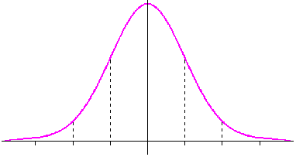
- Step 3: Find the p-value of the sample proportion $\hat{p}$

- Step 4: Draw conclusions

3. Approximately 8%* of pregnant women in the US reported smoking in 2014. Is the rate of smoking higher than this in NC for women 35 and under?
Clearly label your hypothesis testing steps and include an appropriate graph.

*www.childtrends.org/indicators/mothers-who-smoke-while-pregnant/
4. a) Looking just at women who smoked, create a 95% confidence interval for the proportion of babies who were premies in NC.

b) Looking just at women who did not smoke, create a 95% confidence interval for the proportion of babies who were premies in NC.

